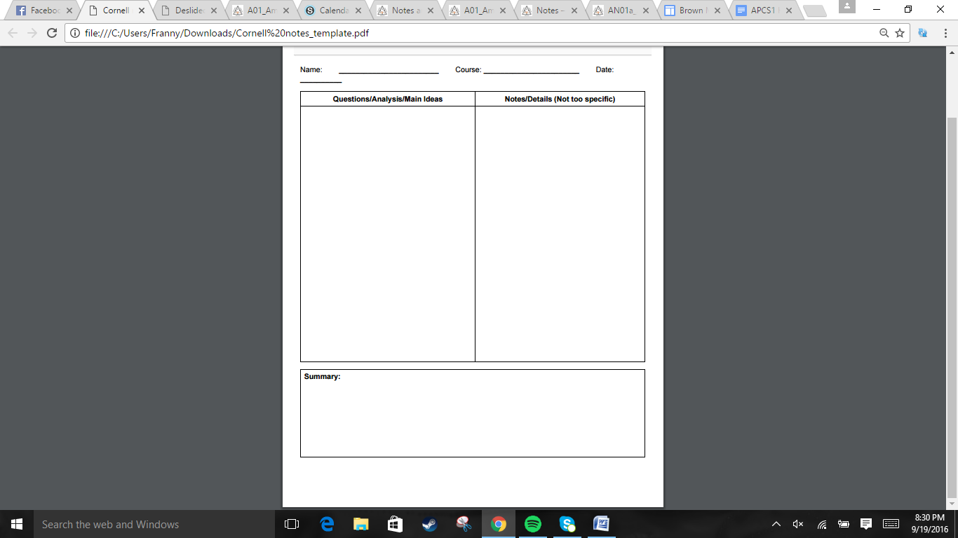  
  
  
  
  
  
  
  
  
  
  
  
  
  
  
  
  
  
  
  
  
  
  
  
  
  
  
  
  
  
  
  
  
  
  
  
  
  
  
  
  


- The Judiciary Act of 1789 allowed the Supreme Court to have a chief justice and 5 associate justices. It also set up 3 federal circuit courts and 13 federal district courts. The act also allowed state court decisions to be appealed by federal courts.  
. Congress created the Department of State for foreign affairs, Department of War, and the Department of the Treasury. Washington appoint department heads that would later be known as the Cabinet.  
-Hamilton believed in commerce, industry, a strong central gov led by the elite. Jefferson distrusted a strong central gov and the rich, favoring a society of farmers  
- He also proposed that the federal gov assume the debts of states to get support from creditors, but this made many Southeners who paid off their debts angry  
-Hamilton managed to get Congress and Washington to establish a national bank, but James Madison argued that this would support the rich and it was not in the Constitution.  
-Hamilton suggests moving the capital south to get more support for the 1790 debt bill.  
-Hamilton supporters of a strong federal gov were Federalists. Jefferson supporters of strong state govs were Democratic-Republicans. A two-party system was well established.  
-Hamilton placed an excise tax on whiskey to make even more money. Frontier farmers became angry and rebelled, but Washington put down the rebellion without any deaths.

The government details the powers of the judiciary and executive branches. During Washington's presidency, a split between Federalist Hamilton and Democratic-Republican Jefferson led to the two-party system. Hamilton's excise tax on whiskey leads to the 1789 Whiskey Rebellion, which was put down by the federal government without a single death, showing the strength of the federal government.

Jonathan Quang US History 11/14/2016

Chapter 6 Section 1: Washington Heads the New Government

How does the new government take shape?  
 -Judiciary Act of 1789  
 -Executive Branch under Washington gets split into branches and the president's cabinet is also made.

What debate occurred between Hamilton and Jefferson?  
 -Hamilton favored strong central gov, Jefferson favored limited central gov.  
 -Hamilton's economic plan involved federal gov paying 2/3 of debt, and states paying 1/3  
 -The Bank of the United States was established  
 -To appease Southerners, Hamilton suggested moving the capital to the Potomac

What were the 1st political parties and what rebellion happened?  
 - A split formed in Washington's cabinet.  
 -Hamilton's excise tax on whiskey cause a rebellion, that was successfully put dow.

- France expected help from the US furing their revolution. Demo-Repub wanted to support France, while Federalists wanted to back the British. Washington took a position of neutrality in 1793. Earlier, Edmond Genet was sent to get support for France in the US, but he violated diplomatic protocol, which angered Washington.  
- Spain agreed to Pinckney's Treaty of 1795, which allowed the US all territory except Florida and use of the Mississippi River.  
-Native American soften attacked white settlers moving into their territory. In 1790, General Harmar's troops clashed with a Native Amer. Confederacy led by Little Turtle. The Native Americans won that battle and the one the year after.  
- 1794, General Wayne defeats the Miami Confederacy, marking a trend where the US took land and paid the Natives less than what it was worth- France saw the Jay Treaty (regarding the Appalachian mountain) as a violation of its alliance with America. 3 men were sent to France, but three low level officials demanded money to allow them to see the foreign minister. => XYZ affair =>unofficial naval war  
-the Alien and Sedition acts had 3 acts that targeted immigrants and one that targeted anyone hindering or badmouthing the gov   
-Virginia and Kentucky claimed the right to void Federal Laws that went beyond Constutitional powers, but the issue died out by the next election.

Section 2: Foreign Affairs Trouble the Nation  
How did the US respond to European events?  
- The official US stance on the French Revolution was neutrality  
-The Spanish give up all their American territory except Florida.

How did Native Americans deal with the US settlers?  
-Native Americans had some success with resistance in the Northwest Territory

-The Battle of Fallen Timbers saw the domination of US over the Natives.  
  
  
Why is President Adams Criticized?  
-Adam tries to avoid war with France  
-The Alien and Sedition Acts were anti-immigration, which angered the active immigrants in the Demo-Repub party.  
-Virginia and Kentucky Resolutions asserted the principle that states could nullify any Congressional act that was unconstitutional.

Jonathan Quang US History 11/14/2016

The US was neutral toward the French Revolution, and made a very good deal in their favor with the Spanish. As the US expanded, they faced some Native resistance. Washington's 8 years were over, and James Adams won the election. He made some controversial choices.



-There was an electoral deadlock between Jefferson and his running mate, Burr. Hamilton manages to convince some federalists to vote for Jefferson to end the deadlock. From then on, Prez and VP positions were voted seperately  
-Jefferson walked to his own inauguration, tried to shrink the size of the government, reduced spending, and tried to reduce the national bank's influence to promote free trade  
- Adam filling the judicial appointments with Federalists angered Jefferson. Adams also increased the # of federal judges to 16 with the Judiciary act of 1801, and filled those positions near the last day of his presidency  
- Madison, the secretary of state of Jefferson, did not deliver the judge appointment papers of Marbury. Marbury sued him under the Judiciary act of 1789, but John Marshall ruled it unconstitutional  
- 1800, Napoleon persuaded France to return the Louisiana Territory. To prevent the US from having to ally with the British, Jefferson sends Monroe to Livingston, and the two close the deal for the purchase of the Louisiana Purchase in 1803. Napoleon had no plans for an American empire after losing Saint Domingue.  
-To explore the newly acquired land, Lewis and Clark are sent on an expedition. They also recruited Native interpreter Sacajawea. It took 2 years and 4 months.

Section 3: Jefferson Alters the Nation's Course  
What happened during Jefferson's election?

What did the Jefferson presidency accomplish?  
-Jefferson tried to simplify the federal government  
  
-His presidency marked southern dominance in the presidency  
-Jefferson tried to argue that Adam's judge appointments were invalid  
-Marbury v. Madison affirmed judicial review, the ability for the Supreme court to declare an act of Congress unconstitutional.  
  
How does the United States expand west?  
- Jefferson acquires the Louisiana Purchase, nearly doubling the size of the US.  
-The famous Lewis and Clark expedition

Jonathan Quang US History 11/14/2016

Jefferson had some trouble being elected, which led to the VP and Prez ballots being separate. Jefferson reduced the footprint of the national government, brought about southern dominance, and had certain judicial events occur. The US also ~doubles in size via the Louisiana Purchase.



Jonathan Quang US History 11/14/2016

Section 4:The War of 1812  
Why did the War Hawks demand war?  
-Americans angered by British impressment.

-Tecumseh's Confederacy grows stronger  
  
  
  
-The war hawks call for war against Britain after discovering British Canadian weapons.  
  
  
What were the results of the war of 1812?  
-The war had mixed results  
  
-The British blockade showed that their navy was winning by numbers.  
  
-The British burn the white house.  
-Andrew Jackson achieves national fame for defeating the Creek tribe and defeating the British at New Orleans.  
-Treaty of Ghent in 1814

The US gets angered by mainly the British. They took US ships, drafted American sailors, and supplied enemy Natives with weapons. The war of 1812 had mixed results in terms of battles and damages. Eventually an armistice was declared in 1814.

-Though both France and Britain were seizing US ships, British impressment of Americans angered the US more. There was also the *Chesapeake* incident of June 1807. The Embargo Act of 1807 was made, but it ended up hurting the US more => embargo restricted to just France and Britain  
-Tecumseh did not give into Harrison's offer for Native American land. Tecumseh and his brother gathered followers and used returning to traditional beliefs as their platform. He tried to get the British and other Natives to join  
-1811- Battle of Tippecanoe, while Tecumseh was absent, his brother led an attack. Harrison won and was made a national hero. It was discovered that some of the Natives were armed with British Canadian weapons. Young Congressmen known as the war hawks from the South and West called for war.  
-Detroit was capture by the British, Commander Perry defeated a British fleet at Lake Erie, and Detroit was retaken. Different Natives fought for different sides.  
-The US Navy only had 16 ships. Three warships had victories but by 1812, Chesapeake and Delaware were blockaded. By the end of 1813, most American ships were stuck in port  
-In 1814, the British were raiding Atlantic coast towns. They burn the White House in retaliation for the Battle of York where the US burned the governor's mansion and legislative buildings.  
- The Treaty of Ghent declared an armistice, though it did not address the causes of the war. They were addressed over the course of a few years until 1818.